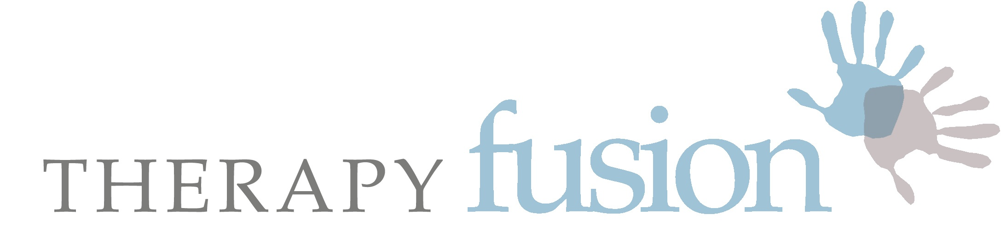

Healthcare and Rehabilitation Services

Course Information & Booking Form

Thank you for enquiring about a place on one of our training courses:

Please read the following details and before completing the form below please contact the host to ensure there are places still available. The pre-requisite to attend Part 2 is completion of Part 1. If you have any queries, please email Michelle at: info@therapyfusion.com

Looking forward to working with you!

Connective Tissue & Fascia: A Forgotten Interface
A Practical workshop – Part 1

Have you ever wondered why treating one area of the body can create a cascade of changes in other tissues, organs and systems … sometimes far away from the symptoms? This ripple effect can be explained in part by examining our connecting tissues – our fascia, and of course our nervous systems.

As manual therapists, tremendous changes can be seen within minutes when our techniques are the right ones for our patients / service users, and our clinical reasoning is more than just guess work. For some of our neurologically impaired patients the changes can still be quick, but for others, the need for complex problem solving, over a longer term, is more often the case.

Please join me for a practical workshop which is patient-focused and clinically relevant. Techniques can be used in intensive care or in the community. Let us discuss how the latest information on fascia and the nervous system may help offer new avenues of exploration for manual treatments and for explanations for the changes seen, especially in regard to spasticity. The course should also promote a better understanding of the connective tissue and fascial layers that give the body complete continuity – and this you will see in each other, during in vivo video clips, and in yourself.

In the past, the existence and relevance of such tissues during mobility, stability and pathology has been poorly understood. This is a fairly new area of discovery and research. Discussions will include some of the recent findings from the World Fascial Research Conferences, the British Fascia Symposium in 2018 and additional papers up to the present. This new information should assist with clinical reasoning during all stages of rehabilitation. Research findings and practical discoveries will be relevant for all manual therapists and should support lively debate in relation to a “Hands on” or “Hands off” approach.

Practical sessions and discussions include a selection of manual treatment techniques and can be applied to many areas of clinical practice.

The patient, and the care we give them, their families and carers, is always at the centre of our workshops.

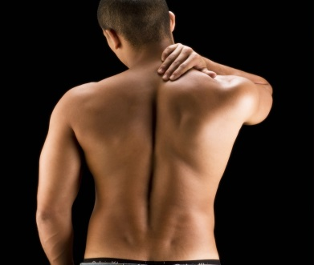 | 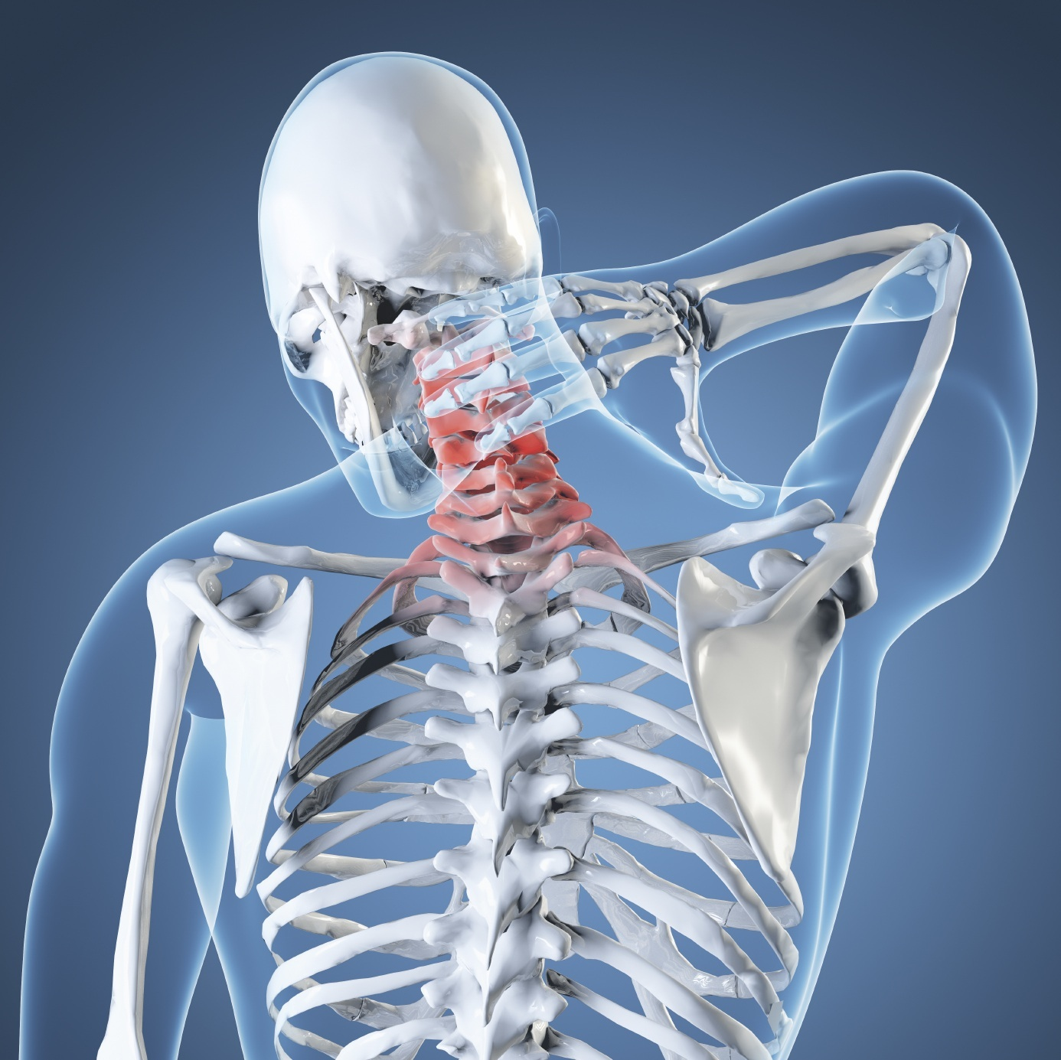
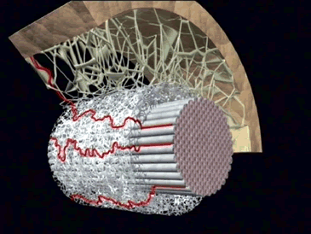 | 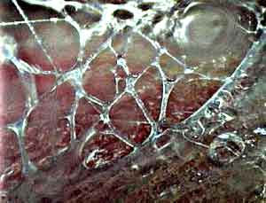
Michelle Watson MSc CertEd MCSP, Chartered Physiotherapist

Michelle qualified as a Physiotherapist in 1995 in the UK. Her specialist field is adult neurological rehabilitation, but she has gained experience in many areas of physiotherapy whilst working for many years in the National Health Service in the UK, in the private and state sector in the USA, and also during 2 years of voluntary paediatric physiotherapy in Zambia, Africa.
Her Masters degree specialised in the field of manual musculoskeletal physiotherapy – the MMACP approved course at Coventry University. Having completed her Masters in 2005, she worked as a Senior Lecturer on the BSc and MSc Physiotherapy course at Coventry University. Following clinical research, she has presented internationally, and continues to run training courses in the UK.
Michelle has been the Director of Therapy Fusion Ltd since 2007, a company that consists of 23 experienced therapists, who specialise in a variety of different fields of healthcare and rehabilitation. The team is very client focussed and work with children, adults and their families and carers, who have a variety of long-term conditions. She is also a fully qualified practitioner in Myofascial Release Therapy, the Bowen technique, and is a trained Bobath Therapist.
Michelle completed a chapter in a book for Leon Chaitow ND DO, entitled: "Fascial Dysfunction - Manual Therapy Approaches", which was published in September 2014. She has also been on the organising committee for the British Fascial Symposium May 2014, and was a main auditorium speaker.
Michelle is married, and is Mum of two cheeky, lovely children.

Part 1: Connective Tissue and Fascia – A Forgotten Interface.

A one-day research update and practical workshop for those working in adult neurological rehabilitation.

Date: Various available: please reference the date you are applying for on your form

Venue: Check with host

Course Programme

8:45 - 9.15am Registration

9.15 - 11.00am Introduction, aims, background theory, evidence, discussion:

CT & Fascia: Definitions, neuropathology, the 3D continuum
Latest dissection / in vivo research evidence

11.00 - 11.20 Break

11.20 - 13.15 Myofascial Practical Session and discussion

13.15 - 13.45 Lunch

13.45-15.45 Further practical session with additional clinical relevance including overview of spasticity management vs low tone / ataxia

15.45-16.00 Break

16.00-17.00 Discussion, questions, review, ‘what next?’ and conclusions

Learning Objectives

- Define and describe functions of C.T. and fascia
- Discuss the relevance of C.T. and fascia in clinical practice
- Discuss and evaluate current research
- Palpate the skin and superficial fascia – learn a range of basic fascial mobilisation and release techniques with clinical reasoning, which will allow you access to the deeper tissues. Observe changes in yourself and colleagues.
- Practice 5 techniques that can be used in all therapeutic settings, including the community.
- Reflect on own assessment strategies and treatment approaches in relation to adult neurological and general rehabilitation. Discuss new knowledge in relation to management of spasticity and low tone / ataxia.
- Consider new adjuncts to practical techniques in relation to soft tissues and management of acute and chronic patients.

APPLICATION FORM: PLEASE COMPLETE AND RETURN BY EMAIL

Connective Tissue and Fascia Workshop – Part 1

Name:

Address:

Telephone Number:

Mobile Number:

E-mail address:

Place of work:

Profession / Speciality:

Date of course applied for:

In order to secure my place I enclose a cheque

In order to secure my place I have paid by BACS

Please tell us where you saw the advert or information on this workshop.

Signature Date

Booking Conditions:

By Cheque

- Payment of full balances will secure your place. Please make cheques payable to ‘Therapy Fusion Ltd ’ and post to Michelle Watson at the address listed in the footer.
- Please send application form with cheque.
- Once balances are paid they are non-refundable at any time unless the place can be filled.
- All payments will be refunded in the unlikely event that the workshop has to be cancelled.

By BACS:

- Alternatively, please pay Therapy Fusion Ltd, sort code: 40-41-26, account number: 11420844. Please reference “CTCourse and the date of the course you would like to attend.”
- Once balances are paid they are non-refundable at any time unless the place can be filled.
- All payments will be refunded if THERAPY FUSION LTD has to cancel a workshop.

Each workshop includes notes, certificates, and light refreshments. As this is an introductory level course, no pre-reading is required. Please bring a vest / sleeveless t-shirt and shorts with you and expect to perform practical techniques on the spine, trunk and limbs. Please note that lunch is NOT included – bring a packed lunch. Please also bring 2 towels, one to roll up as a pillow and one to lie on.

For all courses at the Therpay Fusion clinic please see directions on the website: www.therapyfusion.com. There is ample free parking. We are based inside Stratford Dental.

All information supplied by applicants is confidential and will only be used for training purposes.

Receipts will be sent if requested once payment has been received.

Thank you. Please don’t hesitate to contact me if you need any further information. Looking forward to meeting you! Michelle

