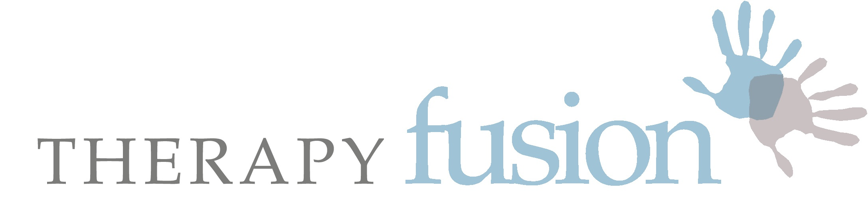

Healthcare and Rehabilitation Services

Course Information & Booking Form

Thank you for enquiring about a place on one of our training courses:

Part 2: Connective Tissue and Fascia – A Forgotten Interface.

Part 2 is a follow-on course to Part 1. The day is packed and includes an interactive practical morning workshop, using manual therapy techniques, complex problem solving of movement dysfunction, and additional research updates. The afternoon will be spent with a symptomatic client, led by Erica Malcolm (former Bobath tutor), and is intended for those working in manual therapy, musculoskeletal / sports rehabilitation. Pre-requisites are Part 1.

Date: Various – check with host

Venue: Check with host

Course Programme

8:45 - 9.15am Registration

9.15 - 11.00am - Welcome & introduction
- feedback use of techniques since Part 1
- brief recap of part 1 theory, review of techniques, evidence and discussion.

11.00 - 11.20 Break

11.20 - 13.15 - Myofascial Practical Session and discussion
- case study examples of how techniques can be used with patients

13.15 - 13.45 Lunch

13.45 - 15.15 Patient demo with Erica Malcolm – interactive.

15.15 - 15:45 Break

15:45 - 16.30 Discussion of patient demo, clinical reasoning, relevance to connective tissues, fascia and use of terminology and clinical language. Conclusion.

Learning Objectives

- Be able to discuss the use of CT and fascial techniques with peers, and patients, using appropriate language relating to the tissues and movements you are evaluating.
- Be aware of current relevant research and be able assimilate this into clinical reasoning relating to choice of approach and outcomes.
- Palpate the skin, superficial and deeper fascia layers – recap a range of fascial mobilisation and release techniques with clinical reasoning, which will allow you access to the deeper tissues. Observe changes in yourselves and colleagues.
- Evaluate case studies and participate in discussion.
- Observe and participate in a patient demonstration in the afternoon, and subsequent discussion.
- Reflect on own assessment strategies and treatment approaches in relation to adult neurological and general rehabilitation.

Connective Tissue & Fascia: A Forgotten Interface
A Practical workshop – Part 2

Please join us for a follow-on practical workshop which is client-focused and clinically relevant. Pre-requisites are Part 1.

The 5 techniques, that we learned in Part 1, can be utilised in most treatment settings, including the home environment. Sometimes the person’s position needs adapting. Let us recap and discuss the techniques used in part 1, learn how to progress these and offer new avenues of exploration for manual treatments, and discuss the changes seen.

Part 2 will also look at the changes seen in 1-2 patient examples who have given permission to be videoed. This will include brief discussion regarding the clinical reasoning behind use of the techniques, and the results observed. This part should enable free discussion between participants regarding their own and other cases, (with permission from those clients), and also promote a better understanding of the connective tissue and fascial layers that give the body complete continuity.

The afternoon session will be led by Erica Malcolm, (clinical specialist in neuro-rehab and former Bobath tutor), and includes assessment and treatment of a symptomatic client. The afternoon will be interactive, so please be prepared to contribute. Once the client has left, there will be time to discuss observations, presentation, treatment approach and what next? There will also be time to discuss the language used to describe what you feel and how you describe the changes seen.

The practical sessions and discussions during Part 2 include a selection of manual treatment techniques that can be applied to many different areas of clinical practice.

The client, and the care we give them, their families and carers, is always at the centre of all of our workshops.

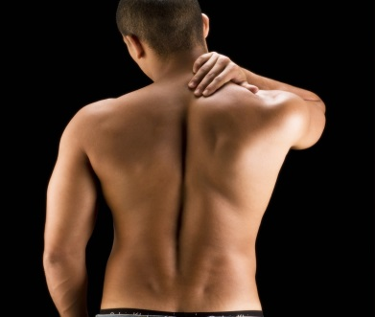 | 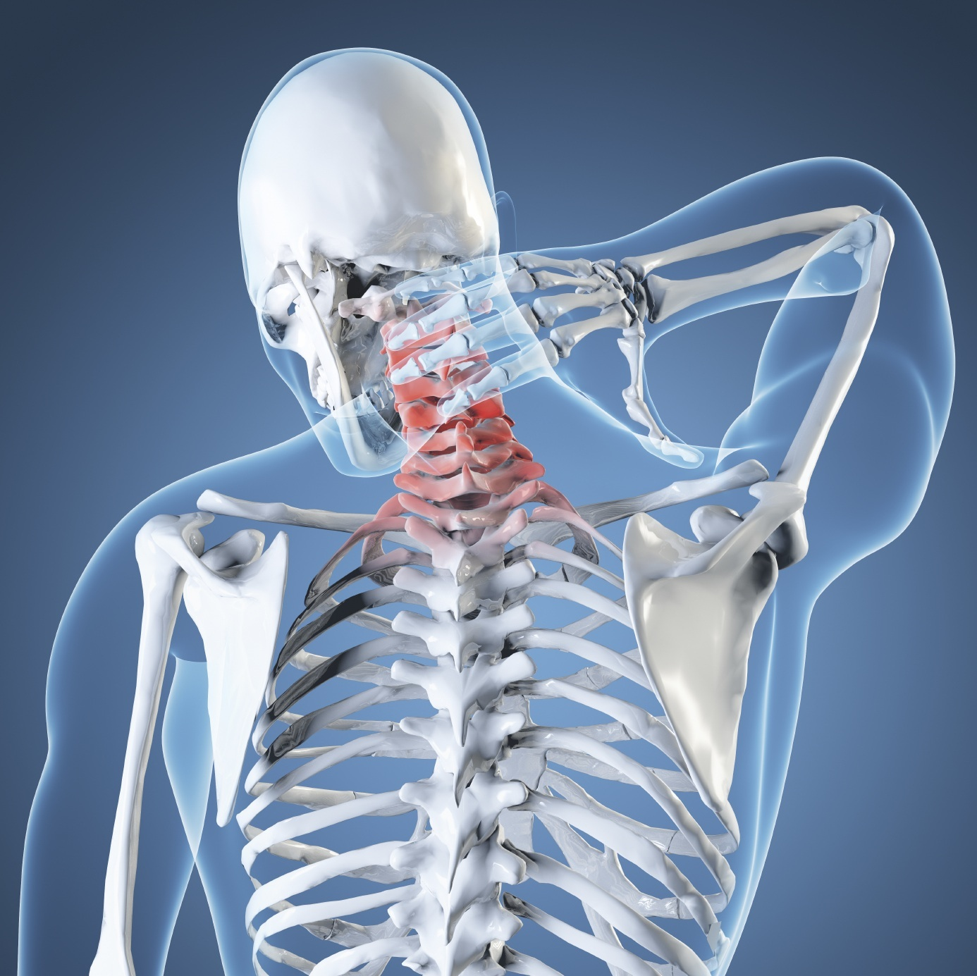
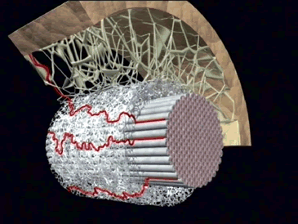 | 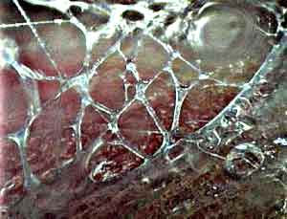
Michelle Watson Chartered Physiotherapist

Michelle qualified as a Physiotherapist in 1995 in the UK. Her specialist field is adult neurological rehabilitation, but she has gained experience in many areas of physiotherapy whilst working for many years in the National Health Service in the UK, in the private and state sector in the USA, and also during 2 years of voluntary paediatric physiotherapy in Zambia, Africa.
Her Masters degree specialised in the field of manual musculoskeletal physiotherapy – the MMACP approved course at Coventry University. Having completed her Masters in 2005, she worked as a Senior Lecturer on the BSc and MSc Physiotherapy course at Coventry University. Following clinical research, she has presented internationally, and continues to run training courses in the UK.
Michelle has been the Director of Therapy Fusion Ltd since 2007, a company that consists of 23 experienced therapists, who specialise in a variety of different fields of healthcare and rehabilitation. The team is very client focussed and work with children, adults and their families and carers, who can have a variety of long-term conditions. She is also a fully qualified practitioner in Myofascial Release Therapy, the Bowen technique, and is a trained Bobath Therapist.
Michelle completed a chapter in a book for Leon Chaitow ND DO, entitled: "Fascial Dysfunction - Manual Therapy Approaches", which was published in September 2014. She has also been on the organising committee for the British Fascial Symposium May 2014, and was a main auditorium speaker. Michelle is married, and is Mum of two children.

Erica Malcolm Chartered Physiotherapist

Erica started Physio Where You Are after realising how difficult it is for people to find a physiotherapist with excellent skills in the treatment of the neurological patient who is prepared to visit you at home at a time to suit you.

Erica qualified as a physiotherapist in 1985 having trained at Nottingham. Her first job was at Glenfield General Hospital in Leicester as well as at the Groby Road Hospital specialising in thoracic surgery. She later moved to Burton on Trent and began to develop an interest in neurology from 1987. This interest deepened as she moved to work at the specialist unit for neurological patients in Derby and eventually became the specialist physiotherapist for neurology across both the Derby Royal Infirmary and the Derby City hospitals. In this capacity Erica carried the responsibility for developing and envisioning the neurological physiotherapy team and to a lesser extent, the occupational therapy services in these Derby Acute Hospitals. Having achieved the aim of creating a cohesive and skilled team in the Derby Acute Hospitals as well as creating working relationships and links with the Primary Care Trusts, it was time to create something new and exciting in the private community setting – that’s where Physio Where You Are comes in!

As well as working in the NHS, Erica qualified as a Bobath Tutor in 1997 at which time she became a member of the International Bobath Instructor Therapists Association. With lecturing commitments all over the country, she eventually decided that she needed to be nearer to home as her young family grew up. Having to relinquish her membership of IBITA, Erica continues to regularly lecture, but now on a more local level. Erica enjoys regularly visiting hospital neurological therapy teams, and undertaking ‘trouble-shooting’ days, leading learning workshops, and developing clinical learning amongst senior neuro-therapy staff.

Having finally left the NHS in January 2007, Erica considers herself privileged to have been asked to continue to work across the Derby Acute Hospitals as a consultant to the neurological physiotherapy and occupational therapy teams.

Like the members of her team, Erica is a member of the Chartered Society of Physiotherapy as well as being registered with the Health and Care Professions Council. Erica is also a member of the Association of Chartered Physiotherapists Interested in Neurology as well as belonging to the Organisation of Chartered Physiotherapists in Private Practise.

All information supplied by applicants is confidential and will only be used for training purposes.

Receipts will be sent if requested once payment has been received.

Thank you. Please don’t hesitate to contact me if you need any further information. Looking forward to seeing you! Michelle and Erica

