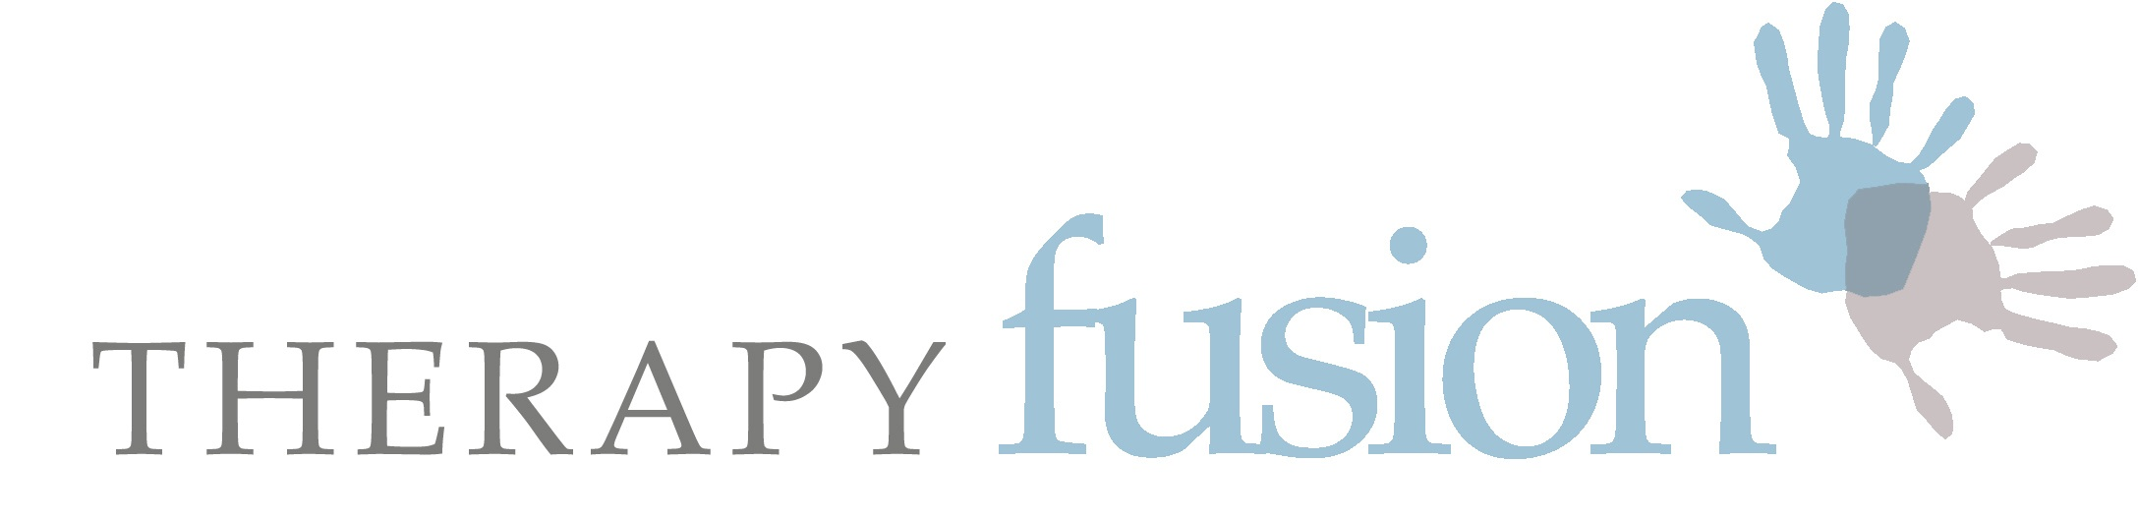

Healthcare and Rehabilitation Services

Course Information & Booking Form

Thank you for enquiring about one of our training courses:

Please read the following details. Before completing the form below please contact the host to ensure there are places still available. The pre-requisite to attend Part 2 is completion of Part 1. If you have any queries, please email Michelle at: info@therapyfusion.com

Looking forward to seeing you!

Connective Tissue & Fascia: A Forgotten Interface
A Practical workshop – Part 2

Please join me for a follow-on practical workshop which is client-focused and clinically relevant. A pre-requisite is completion of Part 1.

The techniques, that we learned in Part 1, can be utilised in most treatment settings, including the home environment. Sometimes your clients position need adapting though. Let us recap the techniques used in part 1, learn how to progress these and offer new avenues of exploration for manual treatments, and discuss the changes seen.

Having run this course for several years it has adapted in lots of ways. The most overwhelming feedback has been that course members benefit greatly from experiential learning. It seems that being treated yourself and assessing and treating others is one of the best ways to apply your new knowledge to your patients / clients.

Part 2 will also look at the changes seen in 1-2 patients who have given permission to be videoed. This will include discussion regarding the clinical reasoning behind use of the techniques and the results observed. Part 2 continues to develop our understanding of the connective tissue and fascial layers that give the body complete continuity.

The whole day is interactive and practical and is filled with complex problem solving of movement dysfunction, plus additional research updates relating to our nervous systems. This workshop is intended for those working in any speciliast field with emphasis on those with chronic postural changes and altered movement patterns.

 | 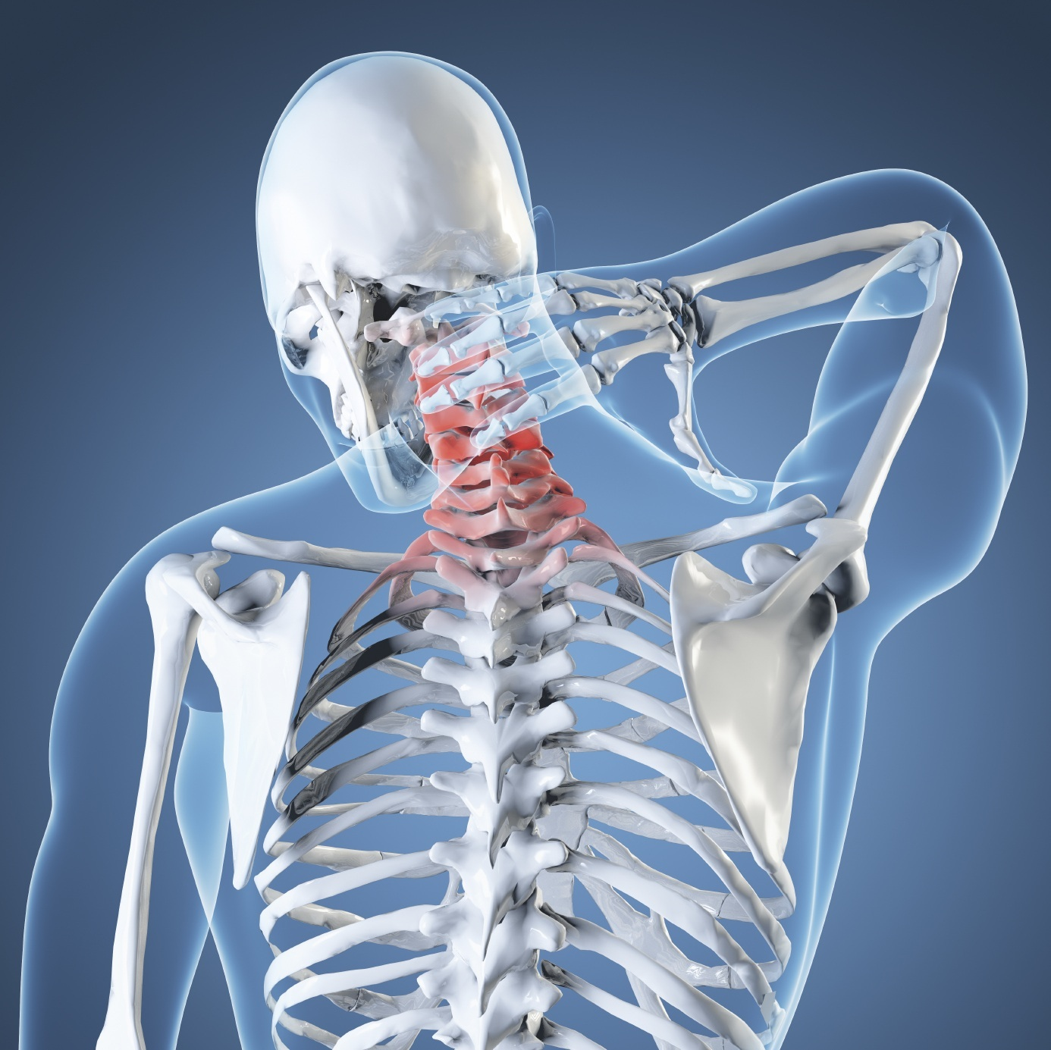
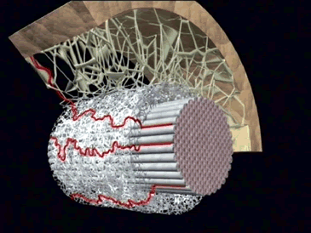 | 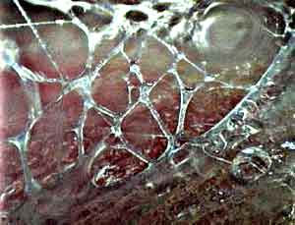
Michelle Watson Chartered Physiotherapist

Michelle qualified as a Physiotherapist in 1995 in the UK. Her specialist field is adult neurological rehabilitation, but she has gained experience in many areas of physiotherapy whilst working for many years in the National Health Service in the UK, in the private and state sector in the USA, and also during 2 years of voluntary paediatric physiotherapy in Zambia, Africa.

Her Masters degree specialised in the field of manual musculoskeletal physiotherapy – the MMACP approved course at Coventry University. Having completed her Masters in 2005, she worked as a Senior Lecturer on the BSc and MSc Physiotherapy course at Coventry University. Following clinical research, she has presented internationally, and continues to run training courses in the UK.

Michelle has been the Director of Therapy Fusion Ltd since 2007, a company that consists of 20+ experienced therapists, who specialise in a variety of different fields of healthcare and rehabilitation. The team is very client focussed and work with children, adults and their families and carers, who have a variety of long-term conditions. Michelle is also a fully qualified practitioner in Myofascial Release Therapy, the Bowen technique, and is a trained Bobath Therapist.

Michelle completed a chapter in a book for Leon Chaitow ND DO, entitled: "Fascial Dysfunction - Manual Therapy Approaches", which was published in September 2014. She has also been on the organising committee for the British Fascial Symposium May 2014, and was a main auditorium speaker.
Michelle is married, and is Mum to two cheeky, lovely children!

Date: Various dates and venues available – please reference the date and venue you are applying for on your application form

Course Programme

8:45 - 9.15am Registration

9.15 - 11.00am Welcome & introduction
Feedback use of techniques since Part 1
Postural assessment with review of previous practical techniques, evidence and discussion.

11.00 - 11.20 Break

11.20 - 13.15 Myofascial Practical Session and discussion

13.15 - 13.45 Lunch

13.45 - 15.15 Further analysis and treatment of each other. Complimented by patient videos showing assessment, treatment, results and progression.

15.15 - 15:45 Break

15:45 - 16.45 Discussion of clinical reasoning, relevance to connective tissues, fascia and use of terminology and clinical language. Further demo if needed. Conclusion.

Learning Objectives

- Be able to discuss the use of CT and fascial techniques with peers and patients, using appropriate language relating to the tissues and movements you are evaluating.
- Be aware of current relevant research and be able assimilate this into clinical reasoning relating to the choice of approach and outcomes.
- Palpate the skin, superficial and deeper fascia layers – recap a range of fascial mobilisation and release techniques with clinical reasoning, which will allow you access to the deeper tissues. Observe changes in yourselves and colleagues.
- Evaluate case studies and participate in discussion.
- Reflect on own assessment strategies and treatment approaches in relation to adult neurological and general rehabilitation.

APPLICATION FORM: PLEASE COMPLETE AND RETURN BY EMAIL

Connective Tissue and Fascia Workshop – Part 2

Name:

Address:

Telephone Number:

Mobile Number:

E-mail address:

Place of work:

Profession / Speciality:

Date of course applied for: _________________________________

In order to secure my place I enclose a cheque for ………

In order to secure my place I have paid by BACS

Please tell us where you saw the advert or information on this workshop.

Signature Date

Booking Conditions:

By Cheque

- Payment of full balances will secure your place. Please make cheques payable to ‘Therapy Fusion Ltd ’ or to a different provider if not organised by Therpy Fusion.
- Please send application form with cheque.
- Once balances are paid they are non-refundable at any time unless the place can be filled.
- All payments will be refunded in the unlikely event that the workshop has to be cancelled.

By BACS:

- Alternatively, please pay Therapy Fusion Ltd, sort code: 40-41-26, account number: 11420844. Please reference Part2Course and the date of the course you would like to attend.
- Once balances are paid they are non-refundable at any time unless the place can be filled.
- All payments will be refunded if THERAPY FUSION LTD has to cancel a workshop.

Each workshop costs £100 - and includes notes, certificates and light refreshments. Please bring a vest / sleeveless t-shirt and shorts with you and expect to perform practical techniques on the spine, trunk and limbs. Please note that lunch is NOT included – bring a packed lunch. Please also bring 2 towels, one to roll up as a pillow and one to lie on.

All directions are on the website: www.therapyfusion.com. There is ample free parking. We are based inside Stratford Dental.

All information supplied by applicants is confidential and will only be used for training purposes.

Receipts will be sent if requested once payment has been received.

Thank you. Please don’t hesitate to contact me if you need any further information. Looking forward to seeing you! Michelle

