Course Information & Booking Form

Thank you for enquiring about a place on one of our training courses.

Connective Tissue & Fascia: A Forgotten Interface
A Practical workshop – Part 1

9.15am - 5pm

Have you ever wondered why treating one area of the body can create a cascade of changes in other tissues and systems … sometimes far away from the symptoms? This ripple effect can be explained in part by examining our connecting tissues – our fascia, and of course our nervous systems.

As manual therapists, tremendous changes can be seen within minutes when our techniques are the right ones for our clients, and our clinical reasoning is more than just guess work.

Please join me for a packed practical workshop which is client focused and clinically relevant. The day will also promote a better understanding of the connective tissue and fascial layers that give the body complete continuity – and this you will see in each other and yourself.

In the past, the existence and relevance of such tissues during mobility, stability and pathology has been poorly understood. This is a fairly new area of discovery and research.

Discussions will include some of the recent findings from the World Fascial Research Conferences of 2007 and 2009, the British Fascia Symposium in 2014, and additional papers up to the present. This new information should assist with clinical reasoning during all stages of rehabilitation. Research findings and practical discoveries will be relevant for all manual therapists and should support lively debate in relation to a “Hands on” or “Hands off” approach.

Practical sessions and discussions will include a selection of manual treatment approaches and techniques and can be applied to many areas of clinical practice.

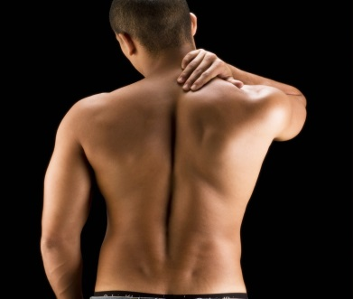 | 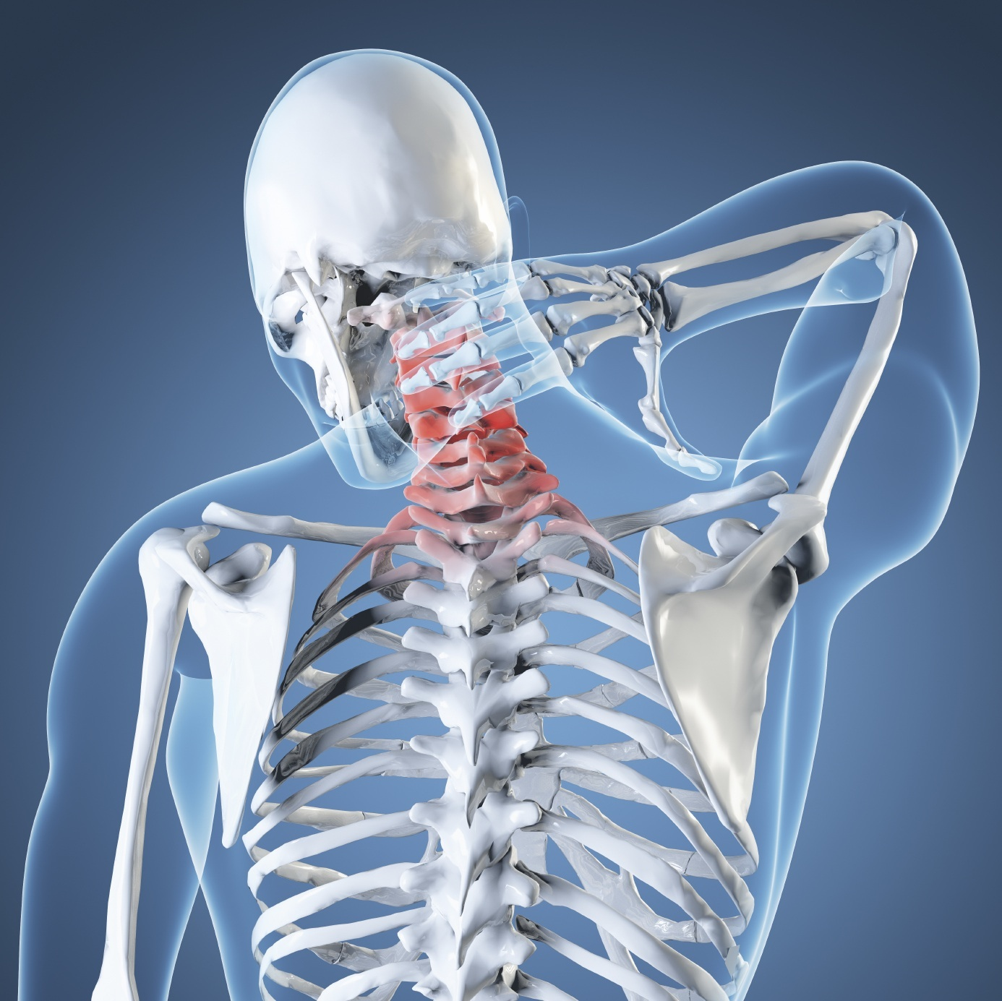
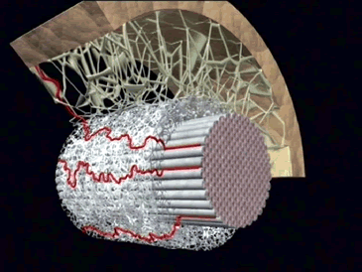 | 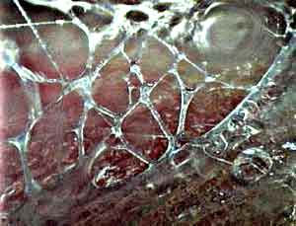
Tutor: Michelle Watson, MSc CertEd MCSP, Chartered Physiotherapist

Michelle Watson

Michelle qualified as a Physiotherapist in 1995 in the UK. Her specialist field is adult neurological rehabilitation, but she has gained experience in many areas of physiotherapy whilst working for many years in the National Health Service in the UK, in the private and state sector in the USA, and also during 2 years of voluntary paediatric physiotherapy in Zambia, Africa.

Her Masters degree specialised in the field of manual musculoskeletal physiotherapy – the MMACP approved course at Coventry University. Having completed her Masters in 2005, she worked as a Senior Lecturer on the BSc and MSc Physiotherapy course at Coventry University. Following clinical research she has presented internationally, and continues to run training courses in the UK. Michelle has been the Director of Therapy Fusion Ltd since 2007, a company that consists of 20 experienced therapists, who specialise in a variety of different fields of healthcare and rehabilitation. She is also a fully qualified practitioner in Myofascial Release Therapy (MFR UK), `The Bowen technique', (a complementary therapy), and is a trained Bobath Therapist.

Michelle has completed a chapter in a book for Leon Chaitow ND DO, entitled: "Fascial Dysfunction - Manual Therapy Approaches", which was published in September 2014. She has also been on the organising committee for the British Fascial Symposium May 2014, and was a main auditorium speaker. Michelle is married, and is Mum of 2 young children.

Connective Tissue and Fascia Update : Part 1

Course Programme

8.45-9.15am Registration

9.15-11.00am Introduction and aims
CT & Fascia: Definitions, neuropathology, the 3D continuum
Latest dissection evidence and in vivo research evidence

11.00-11.20 Break

11.20-13.00 Myofascial Practical Session and discussion

13.00-13.45 Lunch

13.45-15.45 Further practical session with clinical relevance

15.45-16.00 Break

16.00-17.00 Discussion, questions, what next? and conclusions

Learning Objectives

- Define and describe functions of C.T. and fascia
- Discuss the relevance of C.T. and fascia in clinical practice
- Discuss and evaluate current research
- Palpate the skin and superficial fascia – learn a range of basic fascial mobilisation and release techniques with clinical reasoning, which will allow you access to the deeper tissues. Appreciate the effects of function on these tissues and the variety therein.
- Reflect on own assessment strategies and treatment approaches
- Consider new adjuncts to practical techniques in relation to soft tissues and management of acute and chronic patients

Each workshop and includes notes, certificates, use of plinths and light refreshments. As this is an introductory level course, no pre-reading is required. Please bring a vest and shorts with you and expect to perform practical techniques on the spine, trunk and limbs. Please note that lunch is NOT included – bring a packed lunch. Please also bring 2 towels, one to roll up as a pillow and one to lie on.

